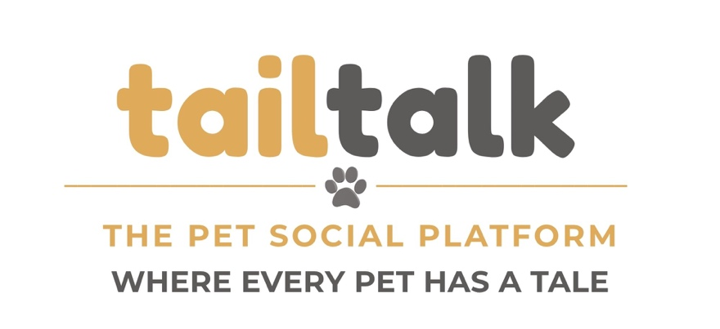

Primary Brand Colors
Gray orange used in the word "tail", the divider line, and "THE PET SOCIAL PLATFORM."
- HEX: #dfaa5a

Gray used for "talk", the paw icon, and "WHERE EVERY PET HAS A TALE."
- HEX: #5d5a5a
Background – White
- HEX: #FFFFFF

Fonts

Logo tailtalk is Fredoka

"THE PET SOCIAL PLATFORM" and “WHERE EVERY PET HAS A TALE” is Montserrat

